Introduction to the Bash Shell

Bash - Overview
What Bash is and why?
- Bash is a command line shell. We use it to run programs in many different way through text only interface.
- Bash gives us access to many UNIX utilities.
- Bash helps to run complex tasks efficiently.
- Some use cases:
  - File management
  - Processing data
  - System administration
  - Remote access
  - Scripting
- Dominant shell on UNIX and comes default on Linux and Mac.

  - Command Line Secession
- We run bash usually on terminal emulator

Host name
User name
Current Working Directory ‘~’

- Checking that are we using bash
  - Command is – echo $BASH
  - Output should be - /bin/bash

  - Commands and Arguments
- A command line consists of words separated by spaces.
- The first word on the input line is the command!!!
- Everything after that is an argument.
  - Example: cd downloads
cd is the command and downloads is the argument
- Options
  - An argument that starts with a dash is called an option.
  - They change the behavior of the command.
Example:
ls -a list all files (including hidden) hidden filename starts with.(dot)
ls -l list files in long format
ls -l -a combine both a and l options
ls -la combine both a and l options
ls -la /bin list all in /bin in long format
  - Notice that the order of options doesn’t matter.
  - Note that the filename has to be at the end.

  - Getting help
- UNIX system has manual pages and the command is man short for manual.
Example:
man ls
man cd
man man

- Using the manual pages
  - Use space to move down a page
  - Move back a page with “b”
  - Search with “/”
  - Exit with “q”

  - Workout
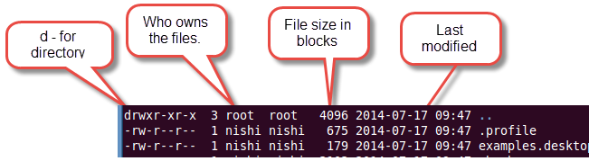

Basic File Management

Creating files and directories

Creating a directory: mkdir

mkdir somefolder Create directory “somefolder”
mkdir a b c d Creates directories a, b, c, d

Creating an empty file

- On existing file it updates modification and access dates
touch x Creates empty file x

Listing text files

- cat
  - Best for small files - no paging!!! Not a pager!!!
  - May mess up your terminal if we use for binary files.
  - Use “reset” to fix terminal
- less
  - Pager with lots of features. It lets you go page by page.
  - See “man less”
  - Use space to move down a page
  - Move back a page with “b”
  - Search with “/”
  - Exit with “q”

About filenames
- Filenames can contain just about anything
  - Except /
  - Hidden files start with a dot
- Case sensitivity
  - “hello” vs “Hello”
  - Linux filenames are case sensitive, Mac OS filenames are not
- Extensions (.exe, .zip) are optional in UNIX. UNIX has its own way to figure out what kind of file it is.
  - “file” command shows type
- Filename dos and don't s
  - Use letters, numbers, - and _
    - If you want to be really safe, don’t use uppercase letters
  - Be careful with spaces Especially trailing spaces

Quoting, Escaping, Completion

- Sometimes we need to deal with the files with filename having special characters.
- Backslash escapes a single character.
- Single quotes - Escape all characters between them
- Double quotes - Don’t use for now
Example:
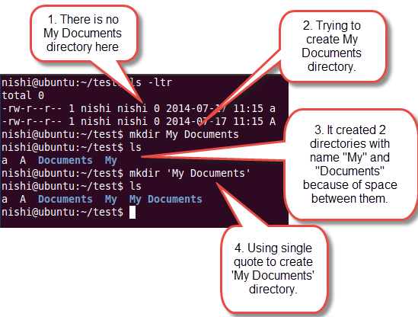

- cd My Documents Error: My: No such file or directory
- cd ‘My Documents’ Ok
- cd My\ Documents Ok
- Remember backslash escapes only a single character, that the character which coming after the backslash.

Absolute paths
- A path represents a location on the filesystem
- Absolute paths
  - Start with /
  - Relative to the root
Example:
/home/reindert

Relative paths
- Don’t start with a /
- Resolved relative to current working directory

Path Working directory Location
Library ~ /Users/reindert/Library
alice ~/demos /Users/reindert/demos/alice
demos/alice ~ /Users/reindert/demos/alice
../demos/alice ~/Library /Users/reindert/demos/alice

Copying files
- cp
- Warning: will silently overwrite existing files!
- Arguments: a source filename and a target filename

Copying directories
- Use cp with the -R switch
- Copies everything in the directory recursively

Moving files
- mv
- Warning: will silently overwrite existing files!
- Arguments: a source filename and a target filename

Deleting files
- rm
- rmdir - Will remove empty directories only
- rm -r - Will recursively remove a directory and everything in it

Using Bash More Effectively

Wildcards
*
- Matches anything
- Including nothing at all
- Example: *jpg, *str*
?
- Matches exactly 1 character

[acd7_]
- Matches one of the characters in the list
- Above would match a, c, d, 7 or _
- [^ax2] matches anything but a,x,2
- ranges: [a-z], [0-9], [A-C3-5]

Brace Expansion
- Generates strings and does not have to match existing filenames.
- Syntax: pre{list,of,strings}post
Example:
Input Expansion
touch {a,b,c}.txt touch a.txt b.txt c.txt
mv file.{txt,jpg} dir/ mv file.txt file.jpg dir
touch {a..c}{1..3}.txt touch a1.txt a2.txt ... c2.txt c3.txt
- Brace expansion comes before wildcard expansion
Example:
mv *{txt,jpg} Documents mv *txt *jpg Documents

Output Redirection
- Redirecting standard output stream
- We use > symbol to redirect the output
- Saves the output of a command to a file
Example:
ls > listing.txt
cat > story.txt
- This will overwrite existing files!
- >> Appends the output to the end of a file
echo “buy milk” >> shopping.txt
echo a{1..5} a1 a2 a3 a4 a5

Pipe
- One of the most powerful redirection.
- Pipe sends the output of one command to input of other command.
Example:
ls | less Pipe tell to use the output of the command before it as the input to the command after it.

Command Substitution
- Replace a command with its output
- Output will become a part of the command line
- Put command between $()
Example:
echo “hello, $(whoami)”
echo “Buy milk” > “notes$(date).txt”
echo “Hello $(whoami), you are on $(hostname) system”
Hello nishi, you are on Ubuntu system

The Terminal and the Command Line
- Bash: Text in, text out
- Terminal
  - Handles keys pressed
  - Draws text
  - Fonts
  - Colors
  - Scrolling
  - Copy/Paste

void Foo()
{
int* iPtr = new int[5];

//manipulate the memory block
.
.
.
delete[] iPtr;
}

